/\*Ashok Rathod JRP 1 Lab 9.12.19\*/

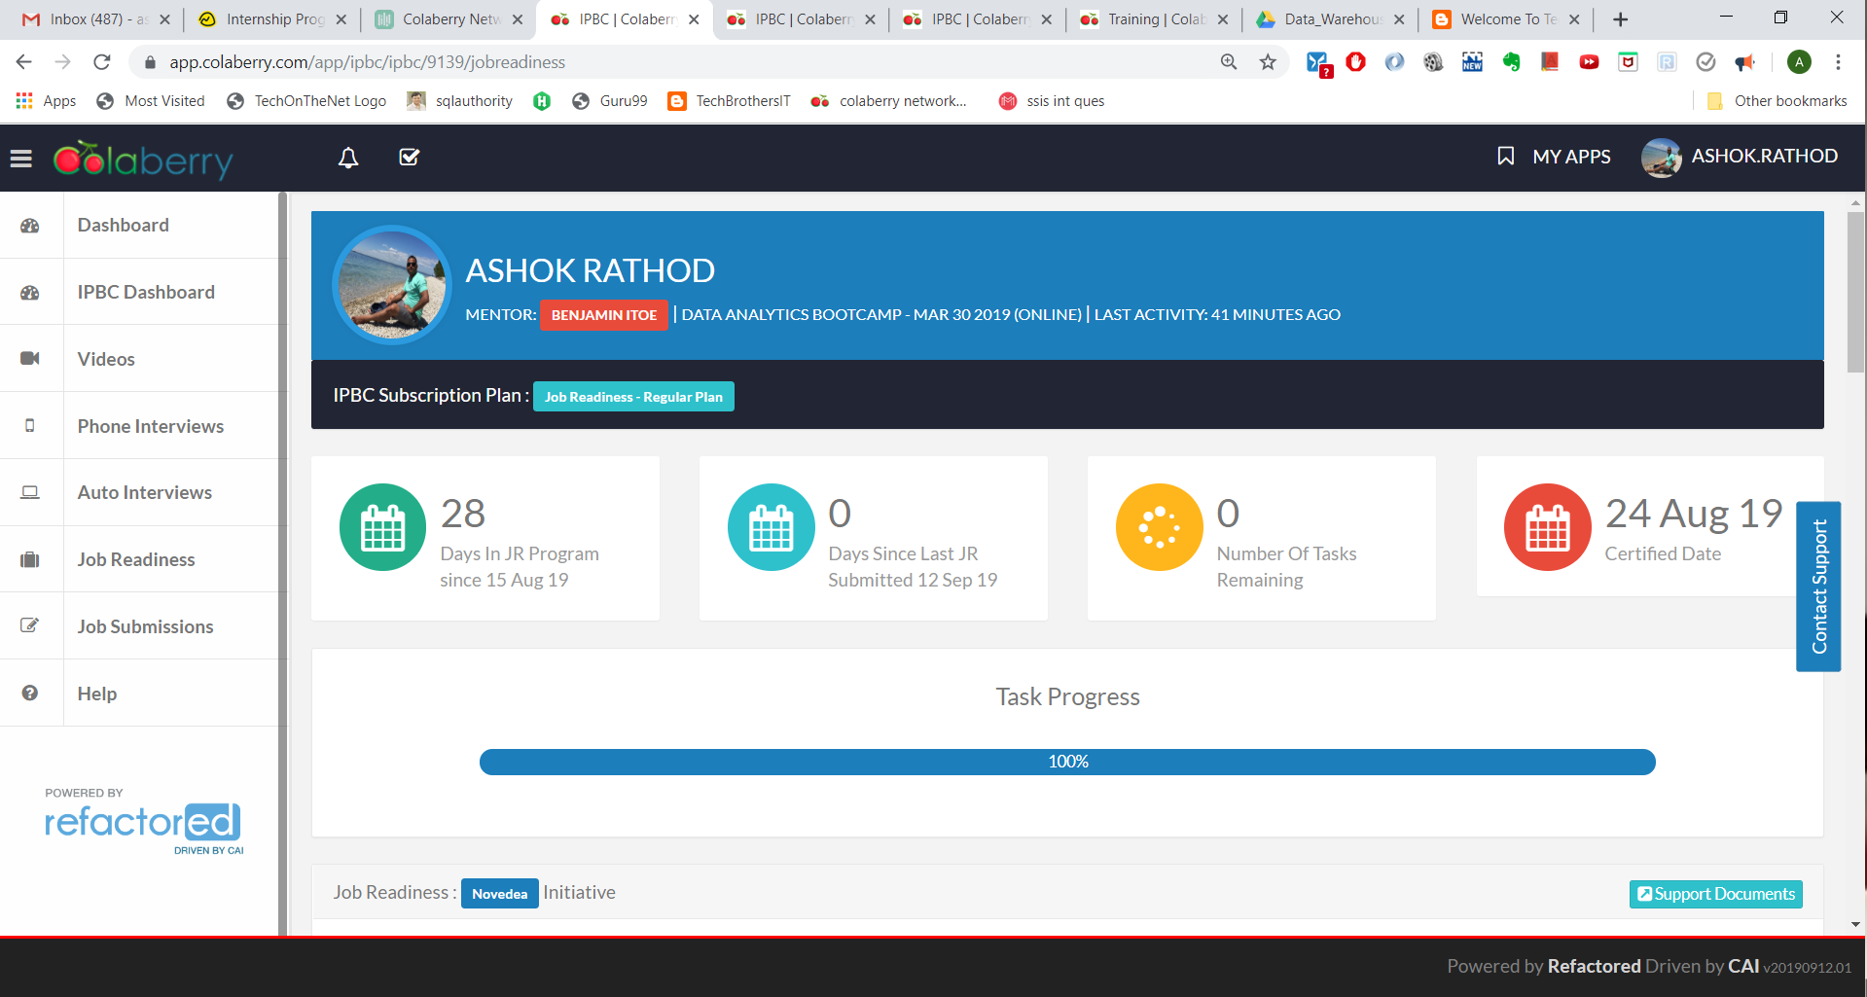

JRP 1 tasks progress